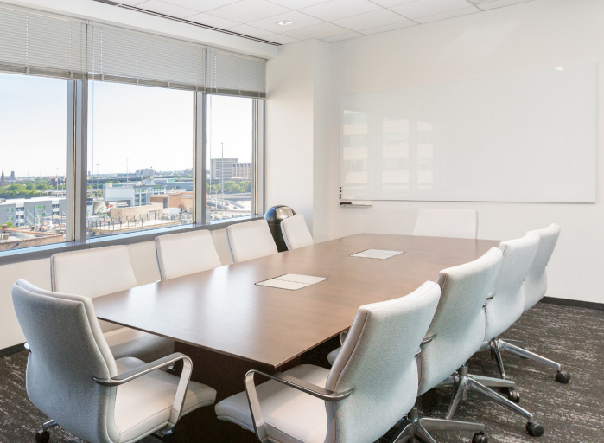 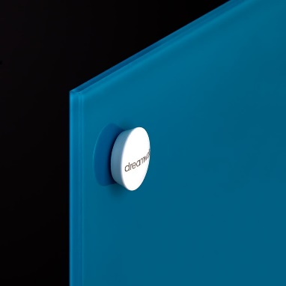



At Dreamwalls®, we strive to help you succeed. With the largest markerboard production capacity in the industry, we can deliver your glass markerboards on time and on spec no matter your project size.

[**Dreamwalls® Glass Markerboards**](https://dreamwalls.com/markerboards/) by Gardner Glass Products offer easy custom color matching, large size formats up to 100 x 144 inches, magnetic options, and additional fabrication options; Dreamwalls® Glass Markerboards take the difficulty out of specifying markerboards for use in elite interiors. With the only heat curing paint process in the industry, Dreamwalls® coatings provide exceptional protection against damage or deterioration. Our boards are completely customizable and clean easily, leaving no lingering marks or ghosting.

Make sure you have the right product to keep your project on schedule and on budget. Contact us for a quote today.

**Gardner Glass Products** are experienced fabricators of glass products with nationwide distribution. For further information, contact Dreamwalls® by Gardner Glass Products, Inc., North Wilkesboro, NC, (800) 334-7267, [www.dreamwalls.com](http://www.dreamwalls.com).

**Specifier**: This document is organized according to CSI MasterFormat and SectionFormat. Bold items require specifier selection. Convert bold to plain text, delete brackets, and removed specifier notes before publishing. Environmental requirements are shown in green and must be edited based on project requirements. This document is compatible with MASTERSPEC and SpecText editing tools.

SECTION 101116

MARKERBOARDS

1. GENERAL
   * + 1. Section Includes
          1. Glass markerboards.
       2. Related requirements

Specifier: Retain this optional Article and edit to provide cross reference to related work results in other sections. Section 088113 “Decorative Glass Glazing” and Section 088126 “Interior Glass Glazing” are available from [Dreamwalls](https://dreamwalls.com/contact/)®.

* + - * 1. Division 01 Section "Sustainable Design Requirements" for general sustainable design requirements including LEED requirements that apply to work of this Section.
        2. Division 08 Section "Glazing" for standard glass products.
        3. Division 08 Section "Mirrors" for mirror glass.
        4. Section 088113 “Decorative Glass Glazing” for back painted glass for interior applications.
        5. Section 088126 “Interior Glass Glazing” for laminated and tempered glass for interior applications.
      1. reference standards
         1. References, General: Versions of the following standards current as of the date of issue of the project or as required by applicable code apply to the Work of this Section.

Specifier: Retain this optional Article and edit to identify standards referenced elsewhere in the Section. Note that inclusion of a standard in this list does not require compliance with that standard; it must also be cited in the Section text.

* + - * 1. American National Standards Institute (ANSI):

ANSI Z97.1 - American National Standard for Safety Glazing Materials Used in Buildings - Safety Performance Specifications and Methods of Test.

* + - * 1. ASTM International (ASTM):

ASTM C1048 - Standard Specification for Heat-Strengthened and Fully Tempered Flat Glass.

* + - * 1. Code of Federal Regulations (CFR):

16 CFR 1201 - Safety Standard for Architectural Glazing Materials.

* + - * 1. United States Green Building Council (USGBC):

LEED Green Building Rating System.

* + - 1. ADMINISTRATIVE REQUIREMENTS

Specifier: Retain one or both paragraphs below if complexity of work justifies requirements.

* + - * 1. Preinstallation Meetings: Conduct pre-installation conference at the site to coordinate Work of this Section with related work.
        2. Sequencing: Schedule installation of glass markerboards to follow adjacent work against which glass markerboard terminates. Schedule installation to follow nearby work whose execution may damage completed glass markerboard work.
      1. ACTION SUBMITTALS

Specifier: Action submittals require responsive action by Architect.

* + - * 1. Product Data: Submit manufacturer's printed data sheets or catalog pages illustrating glass markerboard products and accessories.

Specifier: Retain requirement below when required due to complexity of application; delete when Drawings adequately indicate layout of glass markerboard work.

* + - * 1. Shop Drawings: Submit shop drawings prepared specifically for the Project illustrating layout, dimensions, and other data necessary for satisfactory installation that are not shown in the contract documents.

Indicate glass markerboards types with same designations used in this Section.

* + - * 1. Samples: In manufacturer’s standard size.

Specifier: Retain first subparagraph below if glass markerboard color or finish selections are not indicated.

Initial selection sample for each glass markerboard.

Verification samples for each glass markerboard.

Exposed fasteners.

* + - 1. INFORMATIONAL SUBMITTALS

Specifier: Informational submittals do not require responsive action by Architect.

* + - * 1. Manufacturers' Instructions: Submit handling, storage, and installation instructions.
        2. Sustainable Design Submittals: Submit certifications required in Quality Assurance Article.
        3. Warranty: Sample of proposed manufacturer warranty.
      1. CLOSEOUT SUBMITTALS
         1. Maintenance data for glass markerboards.
      2. QUALITY ASSURANCE

Specifier: Retain paragraph below for projects intended to be LEED-certified and if glass markerboards are installed using adhesives. Add additional requirements that apply. Refer to USGBC LEED Reference Guide for detailed information.

* + - * 1. Sustainability Standards Certifications: Provide the following LEED Submittals:

Credit EQ 4.1: Product data for adhesives, including printed statement of VOC content.

Specifier: Retain paragraph below when layout, patterns, or substrate present installation quality challenges best addressed by viewing of field mockups.

* + - * 1. Mock-ups: Build mockup of each type of glass markerboard installation to demonstrate quality standards for installation.

Approved mockups may be incorporated in the completed Work.

* + - 1. DELIVERY, STORAGE, AND HANDLING
         1. Delivery and Acceptance Requirements: Deliver materials to project site in original sealed packages, with manufacturer's label, and with storage and handling directions.
         2. Storage and Handling Requirements: Store and handle materials in accordance with manufacturer's instructions.

Store in clean, dry location with adequate ventilation for air circulation.

Protect from damage from weather, excessive temperature, and construction operations

* + - 1. WARRANTY
         1. Special Warranty: On manufacturer’s standard form in which manufacturer agrees to replace markerboards which lose functionality due to the deterioration or degradation of the color coated backing within specified warranty period.

Warranty Period: 5 years from date of Substantial Completion.

1. PRODUCTS
   * + 1. MANUFACTURERS
          1. Manufacturer: Project design is based upon products fabricated by Gardner Glass Products, Inc., North Wilkesboro, NC, (800)334-7267, [www.dreamwalls.com](http://www.dreamwalls.com).

Substitution Limitations: Provide basis of design product or comparable product approved by Architect [**prior to bid**] [**in accordance with Division 01 requirements**].

Specifier: Copy article below, re-edit, and re-paste as many times as required for each type of glass markerboard. Create a unique identifier (e.g., GMB#1, GMB#2, etc.) for each type. Verify that Drawings identify and show location of each type. Contact [Dreamwalls](https://dreamwalls.com/contact/) for assistance in editing.

* + - 1. GLASS MARKERBOARDS (GMB#_)
         1. Glass Markerboards:

Basis of Design Product: Gardner Glass Products, Inc., Dreamwalls® [Glass Markerboards](https://dreamwalls.com/markerboards/).

Specifier: Dreamwalls® True White markerboards are more durable and easier to clean than standard whiteboards. Insert color for colored markerboards. Virtually limitless range of colors are available. Color match from any specification (Pantone, Sherwin Williams, Benjamin Moore, RAL, etc.). Spectrophotometer color match available.

Color: [**True White**] <**Insert Color Here**>.

Specifier: Retain one finish below.

Classic Glossy adds that sharp, shiny look to any interior space that only glass can give.

Prosuede© is an acid-etched glass that is fully dry erasable and is 30% more scratch-resistant than regular glass.

Finish: [**Classic Glossy**] [**ProSuede© (matte finish)**].

Specifier: Maximum size is 100 x 144 inches.

Size: <**Insert Size Here**>.

Specifier: Retain galvanized steel backing for magnetic glass markerboards.

Backing: [**No additional backing**] [**1/2-inch plywood backing**] [**3/4-inch plywood backing**] [**Galvanized steel backing**].

Specifier: Metal edging requires plywood backing.

Edge Treatment: [**Manufacturer’s standard polished glass edge**] [**Metal edging**].

Specifier: Coordinate hanging methods with Materials Article below and Part 3.

Hanging Methods: [**Hanging cleats**] [**J-channels**] [**J-channel and shelf**] [**Standoffs**] [**Adhesive**].

* + - 1. MATERIALS
         1. Tempered Glass: ASTM C1048, Kind FT (fully tempered), Condition A (uncoated). Comply with ANSI Z97.1, and CPSC 16 CFR 1201.

Basis of Design Product: Gardner Glass Products, Inc., Dreamwalls® Tempered Glass.

Thickness: 6mm (1/4 inch).

Specifier: With the only heat curing paint process in the industry, Dreamwalls® coatings provide exceptional protection against damage or deterioration. Water-based coatings are available, contact a [Dreamwalls](https://dreamwalls.com/contact/)® sales representative for information.

* + - * 1. Coating: Heat-cured acrylic epoxy and protective paint layers applied to second surface.

Specifier: Coordinate paragraphs below with mounting method indicated in Installation Article. If Adhesive Paragraph is retained, retain option for projects with interior VOC limits such as LEED projects or modify as required.

* + - * 1. Adhesive: Adhesive setting compound, asbestos-free, certified by both glass markerboard manufacturer and adhesive manufacturer as compatible with glass coating and substrates. [**Use adhesive with VOC content of 70 g/L or less per 40 CFR 59, Subpart D (EPA Method 24).**]
        2. Standoffs: Manufacturer’s standard [**chrome-plated steel**] [**nickel-plated steel**] [**stainless steel**] [**brass**] standoffs.
      1. ACCESSORIES
         1. Markers: Box of four dry-erase black markers.
         2. Erasers: Designed for use with dry-erase markers.
         3. Aluminum Wall Shelf: Manufacturer’s standard aluminum wall shelf for direct attachment to wall.

Length: Full length of glass marker board.

Specifier: Delete article below if no magnetic glass markerboards.

* + - 1. MAGNETIC ACCESSORIES
         1. Magnets: Set of ten rare-earth pawn magnets.
         2. Magnetic Marker Caps: To affix dry-erase markers to magnetic marker boards. Provide four.
         3. Magnetic Erasers: With attached magnetic backing to affix to magnetic glass marker board, designed for use with dry-erase markers.
         4. Magnetic Shelf: Repositionable aluminum shelf with magnetic backing.

12 inches.

* + - * 1. Magnetic Buttons: Set of four magnetic buttons, 1 inch diameter.

1. EXECUTION
   * + 1. EXAMINATION
          1. Verification of Conditions: Verify that substrates to receive glass markerboards are plumb, level, smooth, clean, dry, and sound. Correct deficiencies prior to commencing installation.

Specifier: Retain paragraph below for adhesive attachment of glass markerboards.

* + - * 1. Verify compatibility of proposed adhesives with substrate.

Specifier: Retain article below for adhesive attachment of glass markerboards.

* + - 1. PREPARATION
         1. Surface Preparation for Adhesive Application: Comply with adhesive manufacturer's recommendations. Correct minor defects in substrate using leveling compounds acceptable to both glass markerboard and adhesive manufacturers. Prime substrate where recommended.
      2. INSTALLATION

Specifier: Retain option in paragraph below if Shop Drawings are required in Action Submittals Article.

* + - * 1. General: Install markerboard units in accordance with manufacturer's recommendations[ **and approved shop drawings**]. Adjust so glass markerboards are level and mounted at heights indicated.

Specifier: Coordinate installation methods with hanging methods described in Part 2.

* + - * 1. Hanging Cleats: Aluminum; two-piece cleat designed for wall mounting of glass markerboard.
        2. J Channels: Install along bottom, adjusting so glass markerboards are level.
        3. Stand-Off Installation: Drill hole in glass markerboard sized to accommodate sleeve, felt washer, stand-off, and screw at each corner of glass units, located minimum 3 inches (75 mm) from edge of glass. Do not allow screw to touch glass. Do not use adhesive. Hand-tighten screws.
        4. Adhesive Installation: Apply barrier coat to glass markerboard when recommended by adhesive manufacturer. Apply adhesive as recommended by manufacturer. Align glass markerboard units and press into place.
        5. Tolerances: Install glass markerboards to allow for anticipated structural movement.
      1. cleaning
         1. Wash exposed surfaces of glass markerboards as recommended by manufacturer not more than three days prior to scheduled inspection for Substantial Completion.
      2. PROTECTION
         1. Protect glass markerboards from damage resulting from construction activities.
         2. Remove and replace broken or damaged glass markerboards.

END OF SECTION

**Additional Specifiers Notes**

**Substitution Reviews:** When reviewing substitution requests for other products for compliance with this specification, Dreamwalls® recommends particular attention to the following issues:

Quality of glass substrate.

Range of available colors.

Performance characteristics of applied coating.

Terms and conditions of available warranty.

**Coordination with Drawings:** Make sure you coordinate the following:

Location of each glass markerboard unit, using designations from specification or schedule.

Size and shape of each unit, and sizes, shapes, and locations of cutouts and notches.

Detail of edges.

Method of mounting or support.